Echocardiography protocol
University Medical Center Utrecht, February 2019
Echocardiograms should preferably be acquired with a GE machine for standardization of strain analysis. Height and weight of the patient should be registered. All echocardiograms should go along with appropriate ECG recording. At least 3 cardiac cycles should be acquired per view. For patients with atrial fibrillation, at least 5 cardiac cycles should be acquired per view. Doppler recordings should be acquired during end-expiration.
Parasternal long-axis view | 2D/M-Mode  Color Doppler MV/AV  2D focused on RVOT for measurement diameter
Parasternal RV inflow view | 2D (figure 1A)
Parasternal short-axis view
Apical level | 2D
Mid-papillary level | 2D (FR >55/sec)
MV level | 2D (also focus on basal RV, figure 1B)  Color Doppler MV
AV level | 2D  Color Doppler AV  Color Doppler PV  PW RVOT  Color Doppler + CW TV  2D focused image of RVOT for measurement diameters
Apical 4-chamber view | 2D LV/LA  2D LV focused view (FR >55/sec), (figure 2A)  Color Doppler MV  PW MV inflow  TDI PW medial annulus  TDI PW lateral annulus
Apical 5-chamber view | 2D LV/LA  Color Doppler AV  PW LVOT  CW AV
RV-focused apical 4 chamber | 2D RV/RA  2D RV focused view (FR >55/sec)  2D Narrow-angle, RV free wall (FR>80/sec) (figure 1C)  M-mode tricuspid annulus  TDI PW tricuspid annulus  Color Doppler + CW TV
Apical 2-chamber view | 2D LV/LA  2D LV focused view (FR >55/s), (figure 2B)  Color Doppler MV
Apical 3-chamber view | 2D LV/LA  2D LV focused view (FR >55/s), (figure 2C)  Color Doppler MV/AV
Apical 3D view | LV focused (FR >20)
Subcostal 4-chamber view | 2D
Subcostal vena cava inferior | 2D/M-mode (with sniff)
Figure 1: RV-specific echo views. A = Parasternal RV-inflow view; B = RV-focused short-axis view; C = RV-focused apical 4-chamber view.
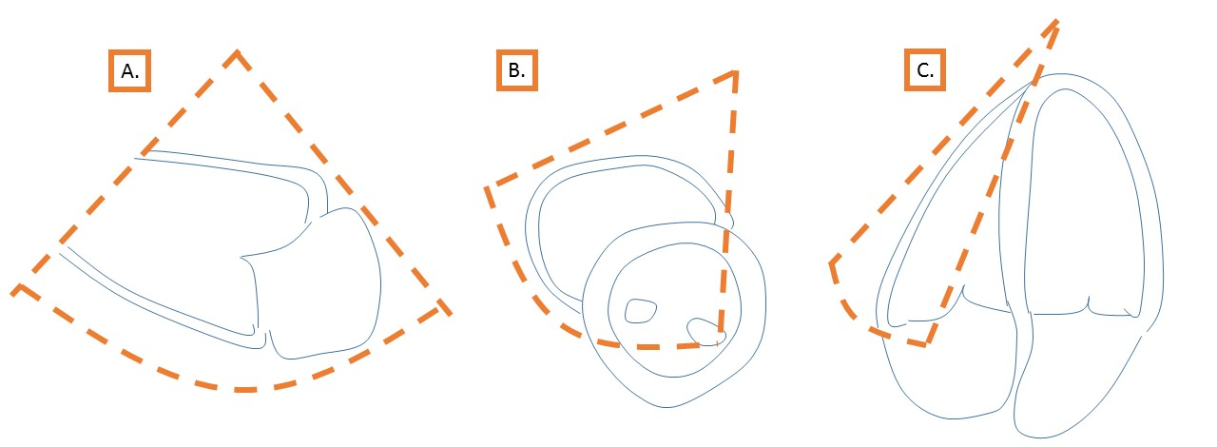
Figure 2: LV-focused echo views. A = apical 4-chamber view; B = Apical 2-chamber view; C= Apical 3-chamber view.
